Welcome to Fair Weather Dog Agility Club. This is a club where you can make new friends, have fun with your dog and sort out any problems or concerns you might have. We cater for all dogs what ever their age or size; small, medium or large.
We show you how to teach your dog to jump over Hurdles, go through Tunnels, climb the A-Frame, go up the Dog Walk, jump through a Tyre, and walk on a See Saw. All this off the lead (well eventually)! It is good exercise for the dog and you don’t need to be fit as the exercise will get you fit! It is a lot of fun for both of you.
As with any club we need to have some basic rules so that the club can run smoothly, so here they are:
Terms and conditions
- The basic 5 week training course costs £60 and is payable on or before the first session. Once the basic course is completed you can still continue to come to lessons.
- Cancellation Policy. This club does not refund any money paid after the first session. If a handler is unable to come to class they will not be entitled to a refund. If the club has to cancel a session/s for any reason, the club will refund that cancelled session.
- Dogs must be kept on their leads at all times unless the trainer specifies otherwise.
- Please bring a flat collar and longish lead for training.
- Please do not feed your dog for at least 4 hours before they come to class because like us, it isn’t good to exercise on a full tummy.
- If you have not been shown how to use the equipment, it can be dangerous to allow your dog on any of the equipment, so please do not allow your dogs onto any of the equipment unless the trainer instructs you otherwise.

- If you dog is coughing, has had an operation, a sore throat or has an upset tummy, please DO NOT bring him/her to club. Let them recover at home.
- If your bitch is in season/heat, please leave them at home until they have finished.
- Dogs must be at least 10 months old before they can start training for Agility
- Dogs less than 12 months of age will not be allowed on specific pieces of equipment until they have matured (usually around 12 months for small dogs and 18 months for larger dogs). This is for their own protection as the growth plates in the joints can get damaged and can cause arthritis later in life.
- You are responsible for the safety of your dog at all times. Remember some dogs are not always sociable towards other dogs so please respect this.
- This club will not be held responsible for any loss, damage or injury to handler’s property, including dogs, or to that belonging to anyone else accompanying them to any training session.
- Children accompanying adults to training sessions must be kept under control at all times and not allowed to climb on equipment or annoy livestock.
- Children are welcome to train their dogs in agility but must be accompanied by a responsible adult at all times.
- Please pick up after your dog if it has an accident and take it home with you.
- Harsh handling of the dogs will not be tolerated.
- This club does not refund any money once paid. If a handler is unable to come to any of the classes they will not be entitled to a refund. If the club has to cancel a session/s for any reason, the club will refund that cancelled session.
- Please telephone before 12pm on Wednesday if you are unable to attend any sessions.

If you wish to enrol on a course, please return the completed form with either £10 non-refundable deposit or £60 for the whole 5 week course to:

Jennie Fairweather
30 Blenheim Drive
Launton
Bicester
OX26 5EA

Cheques made out to:
Fair Weather Dog Training Club

Fair Weather Agility Club

Owner’s Name : ….…………............................................
Address: ……………………………..............……………..............

...............................................................................................

……………………................................................................

Telephone number ……………………………….................

Mobile number ……..…………………………….................

E mail address …. ….…………………………….................

Dog’s name: …………………………
Breed ……..........................

Male/ Female. Date of Birth: ………………………..

Breed ………………………………..................…………..

I wish to enroll my dog on the Basic 5 week Agility course

I understand that this club cannot be held responsible for any loss, damage or injury to handlers, their property (including dogs), or to that belonging to anyone else accompanying them to any training session. I accept responsibility for my dog at all times.

Signed: …………………................................... Date: ………………………………...................

None of the information given will be used for any other purpose except that of the club.

Fair weather
Dog agility
club

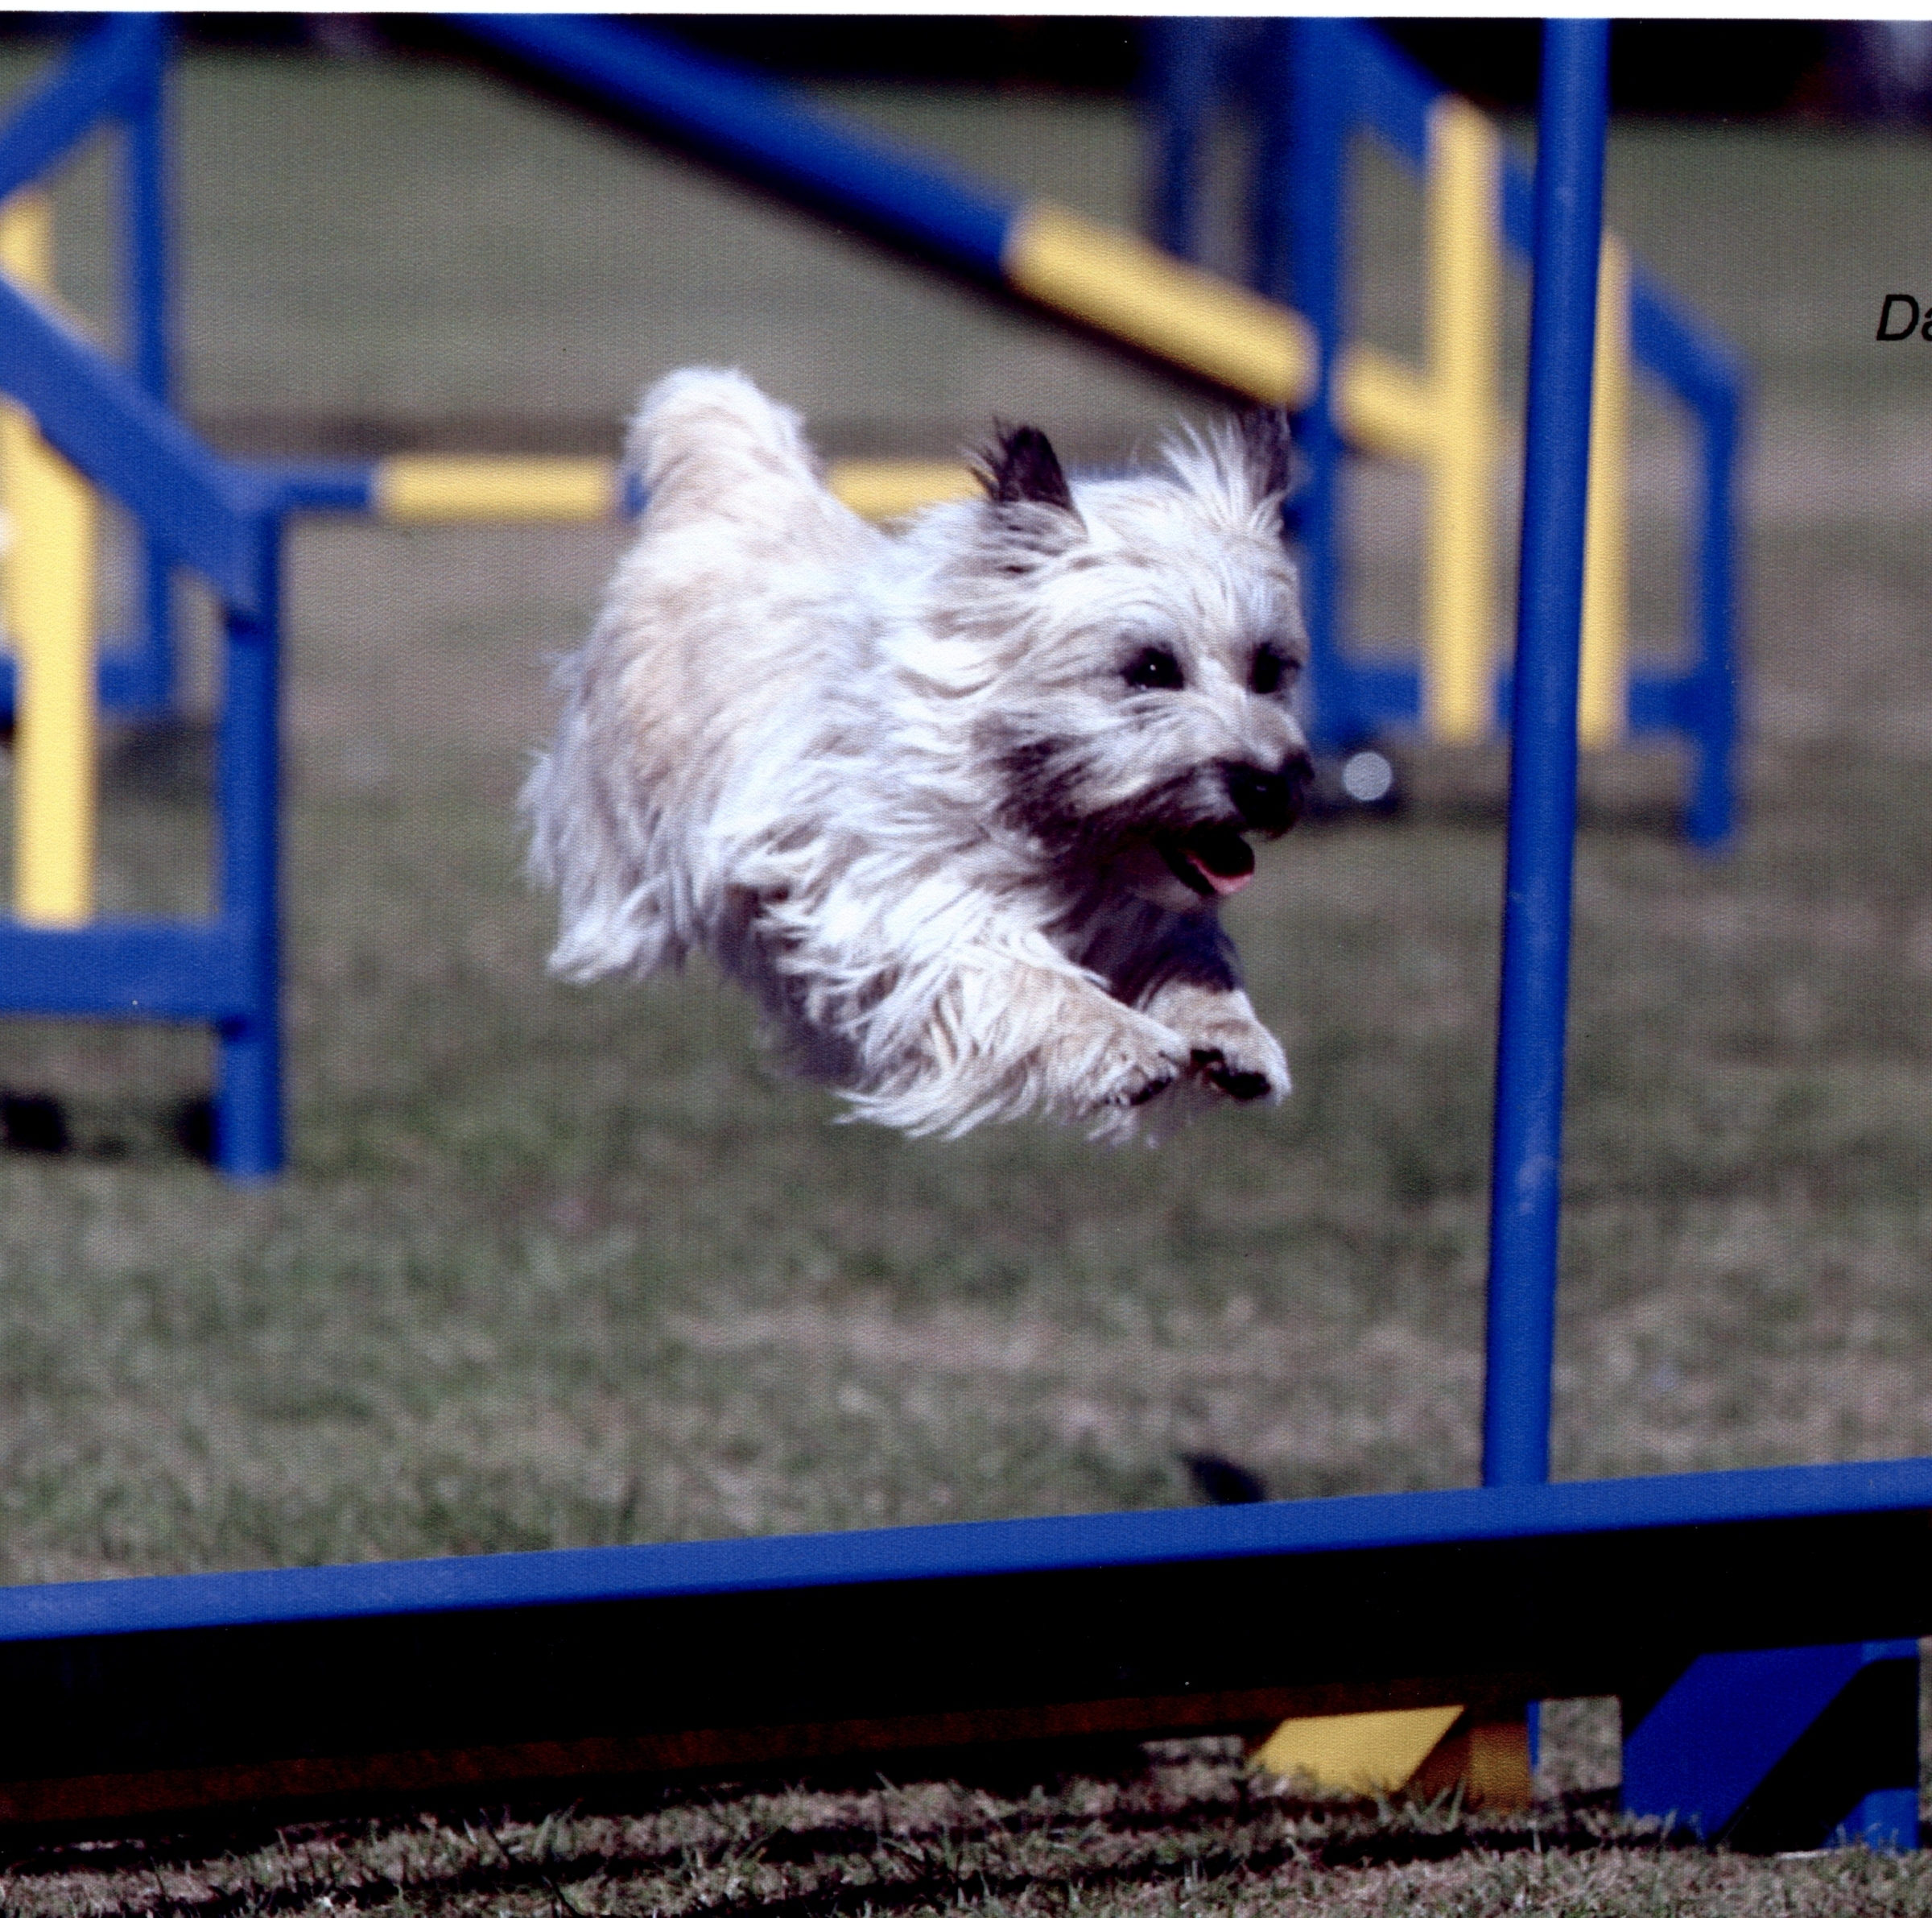
Jennie Fairweather
01869 322996

e-mail ockcairns@yahoo.com

www.fairweatherdogtrainingclub.co.uk

